Setting email alerts in FortiGate

Have-to-now: When sending an email from an external server [FortiGate] to your Microsoft organization account inbox:name@domain.com, the extrnl srvr does “nslookup -type=mx domain.com”: company-domain.mail.protection.outlook.com and sends it the email through port 25 with the only authemtication being the extrnl server’s reputation. [the scenario we are going to set up]
Now if the external server becomes internal (which requires authenticating the FG to let MS know you re internal and often 2FA (not supported by Fortigate)), after authenticating it sends the email to smtp.office365.com which routes the mail to the correct inbox. [to be used if 2FA is off or app password still exists]
Requirements: Admin access + Active FortiCare + Active FortiCloud:
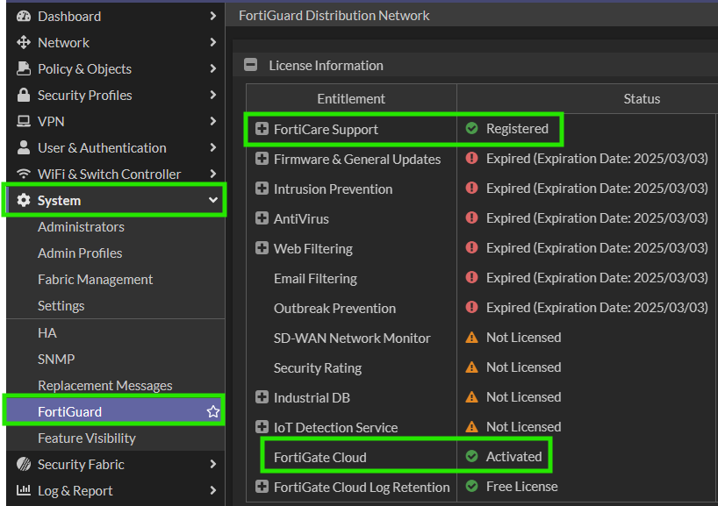

Access the exchange admin center: admin.exchange.microsoft.com
Mail Flow > Connectors > +Add Connector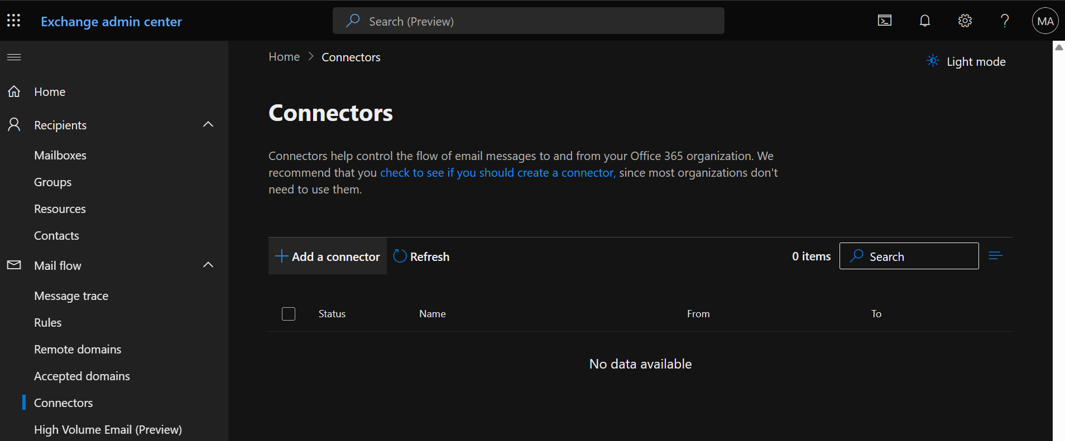
Add a connector: From: Your Org's Email Server -> To: Office 365.
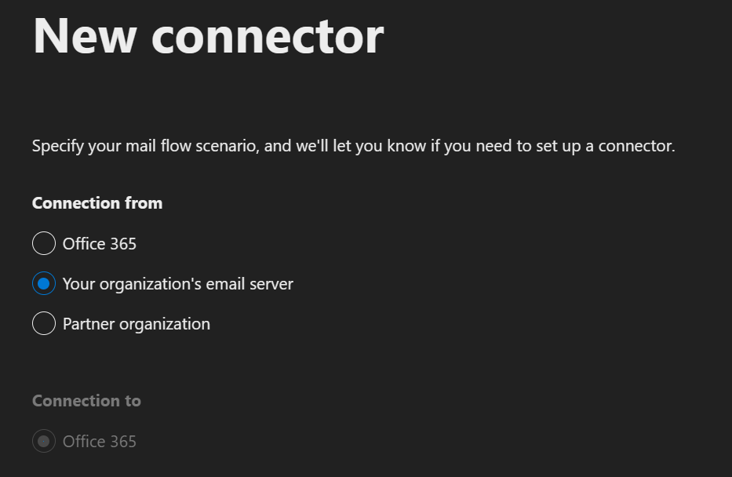 [fortigate == <your organization’s email server>]

Authenticate by IP:
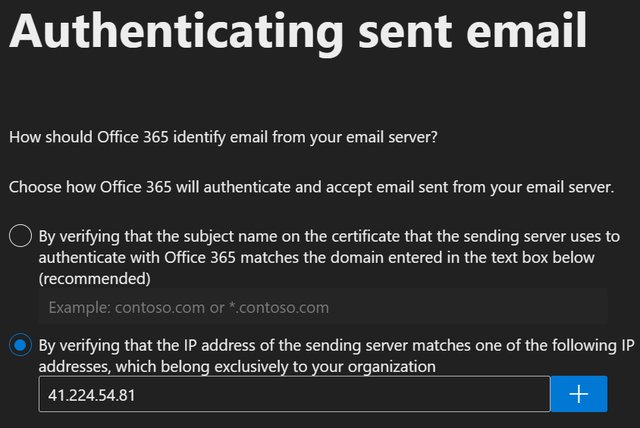
Check Your Domain in admin.cloud.microsoft > Settings > Domains [@company.domain]
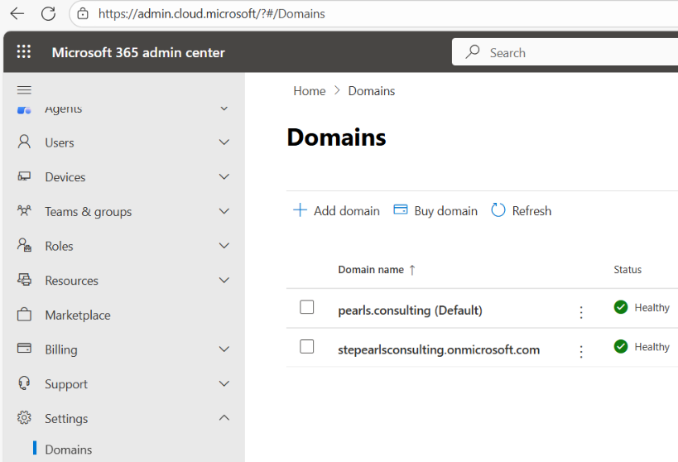

- Now to determine your email server, open powershell or cmd and run or nslookup online:
>nslookup -type=mx company.domain
>>>company.domain MX preference = 0, mail exchanger = company-domain.mail.protection.outlook.com
- Test if the port 25 is open on that server (sometimes it is blocked by ISPs) :
>execute telnet company-domain.mail.protection.outlook.com 25
>>>Connected ✓

Now let’s set this up in Fortigate, Open terminal (GUI, ssh, serial access…):

Steps to set up the mailing system on FG-80F:
CLI >_ :

*Here is the default email-server configuration:
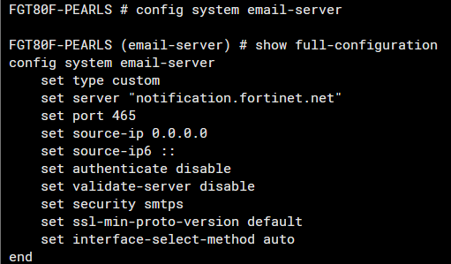

I want to change the default server to my company’s ms email server so alerts do not get flagged as spam, so I am using Exchange Connectors, which should be set up separately [StepsBelow]:
>set server “smtp.office365.com” I tried pingin it to make sure:
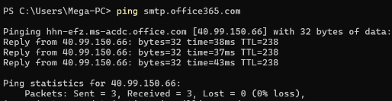
>set source-ip 0.0.0.0: #IP used to request mail server

*Here is the default AlertMail configuration:
>config alertmail setting
>show full configuration
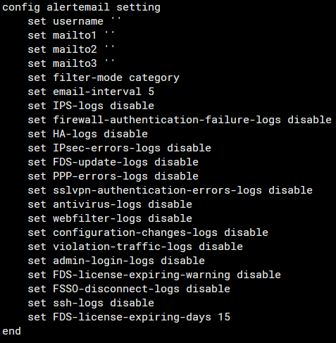
Collect and send the logs every 5min (not instant) set 1 for testing

This gives you an idea of the possible alerts

>config alertemail setting
>set username "user@name.com"
>set mailto1 "<your_email>"
>end

Enable the alerts you want

>config alertemail setting
set HA-logs enable
set FDS-license-expiring-warning enable
set FDS-license-expiring-days 15
end
Finally, to test:

>diagnose log alertemail setting

After 1 minute…:
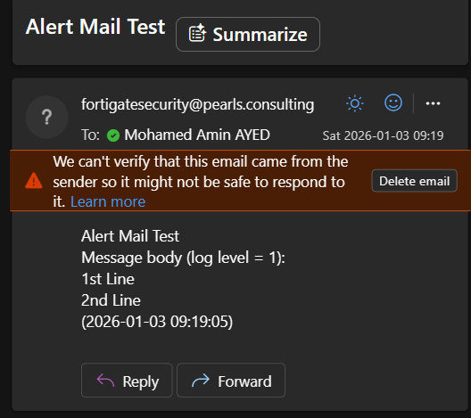

Setting Automation in FortiGate
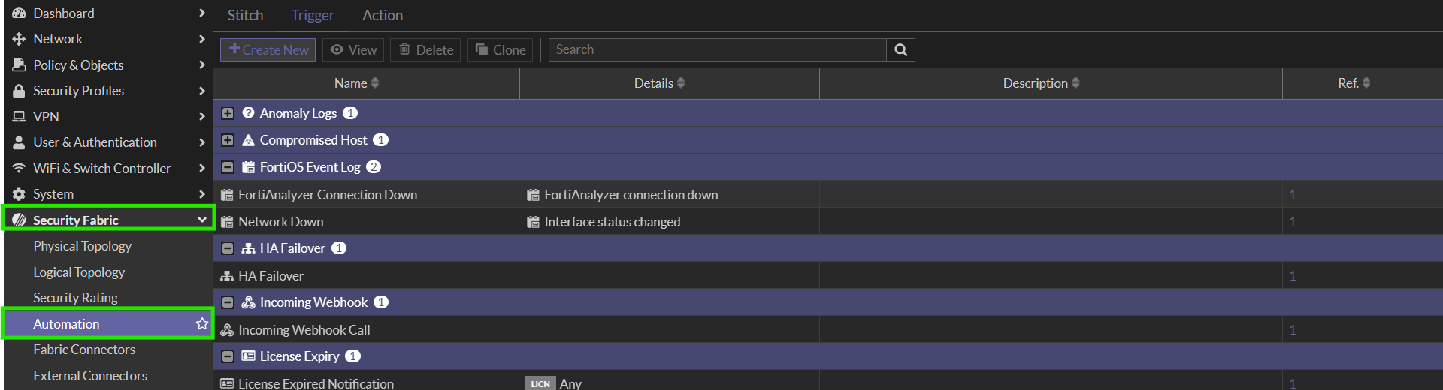
Here we can see the STITCH, TRIGGER and ACTION tabs: TRIGGER provoques an ACTION via a STITCH link.
Let’s start with an email alert on internet loss: so the trigger is internet loss & the action is sending an email

Which means we need a Trigger: (reboot is better to setup as event log iD, because reboot happens before FG can send the mail)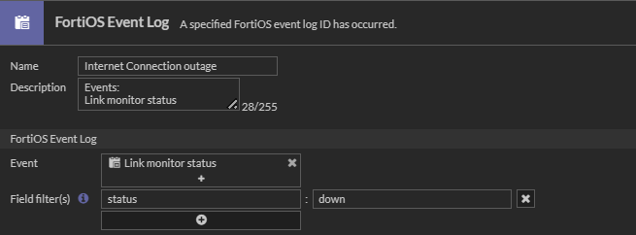
An Action: (From-Mail should match the one in your config)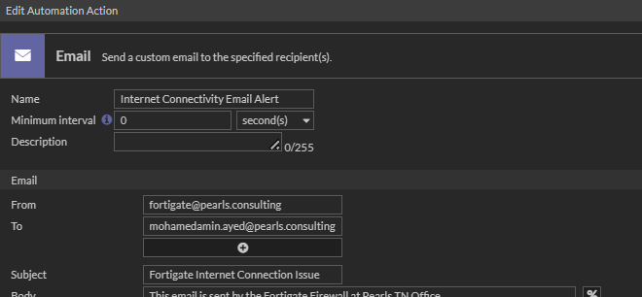
And a Stitch: 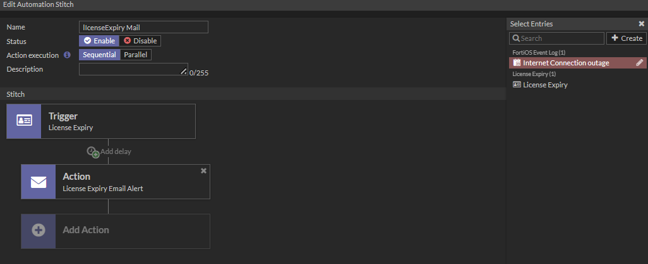

Test the automation:
>diagnose automation test Rebooot "logid=32009 type=event subtype=system level=notice vd=root msg=\"FortiGate started\""
automation test is done. stitch:Rebooot

Event | FortiGate started
ID | 32009
Name | LOG_ID_SYSTEM_START

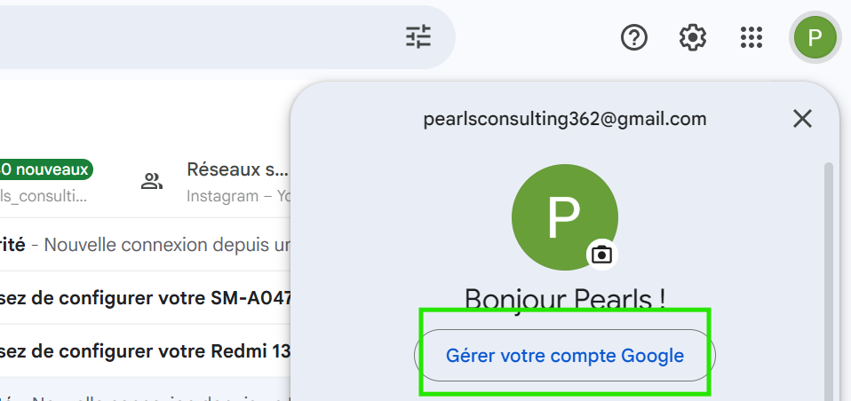
Turn on 2FA , only then can you Create and manage app passwords from this LINK.

Diagnose email sending mechanism:
diagnose debug reset
diagnose debug application alertmail -1
diagnose debug enable
diagnose log alertmail test

